This document is a draft!

Background

Reference Architecture for Action and the document defines the terms Event, Specific Incident and Event Distributor, which shall bind the service-oriented architecture. Together with a background in ’Anbefaling for en generel hændelsesbesked version 1.0’ (Recommendations for a general event message version 1.0), this document contains a proposal for a specific event message that can be handled by the general event message.
Technical Guide for Case and Document addresses the infrastructure and non-functional requirements. This document is a semantic analysis of the incident.

What is an incident?

An event is issued on an incident of an object when its data is changed, i.e. when it is created a new registration.
Case and Document defines a specific incident which is a minimal notifications structure. This is embedded in "extension Structure" from the standard General Event. General Event is like an outer envelope, and the incident is as content.

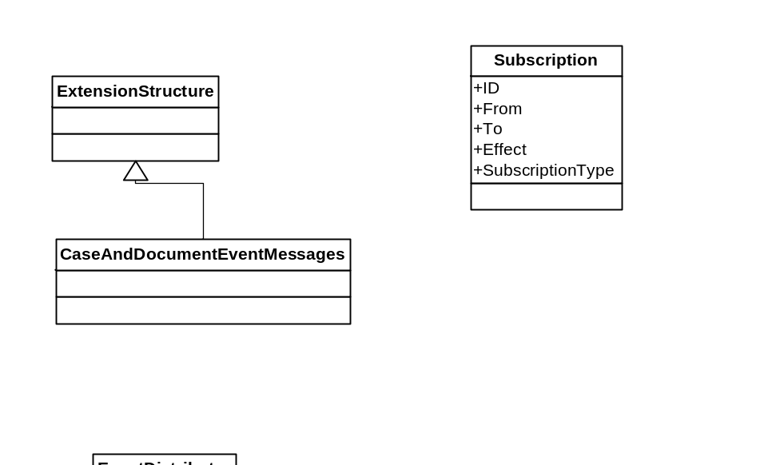
Operation API

Since we will not require the infrastructure that we operate with a minimalist event model, and a push notify architecture. This solution can be offered both in an advanced enterprise environment, but also in an environment with lots of legacy - it's enough to have a URI.

Event Distributor

Event Benefits which has operations Create and Cancel.
By maintain a specified search criteria that represent the resources that you are interested in receiving events.

Event Distributor
Create (Subscription Input Message): Subscription
Unsubscribe (abonnementsID: UUID): Standart Returns

Table 2

Event Receiver

This is a call-back URI, representing a inteface you must have in order to receive an incident.

Event Receiver

Receive (General Event): Standard Return

